**Policy Summary for Military Service Members –**

**(Voluntary Education Institutional Compliance Program – 2024 Service Member Re-enrollment)**

Central Connecticut State University (Central) is pleased to participate in a Voluntary Education Partnership with the United States Department of Defense (DoD). Central ensures compliance with program integrity requirements consistent with the regulations issued by the Department of Defense 2024 Institutional Compliance Program specifically related to restrictions on misrepresentation, recruitment, and payment of incentive compensation to military Service members and/or dependents.

As part of this partnership, Central agrees to follow the Institutional Compliance Program policies and procedures as they relate to Service members eligible for the Tuition Assistance (TA) Program. Please find below important statements, policies, and procedures related to Service members as it relates to recruitment, financial, and enrollment in academic programs.

*The University shall permit returning Service members and Reservist to be readmitted into the same academic program the student was enrolled in prior to the military service obligation (3.i.(1)). Catalog link below:*

*2024-2025 Undergraduate/Graduate Catalog - Undergraduate Student Leave of Absence Policy*

[*https://ccsu.smartcatalogiq.com/en/current/undergraduate-graduate-catalog/undergraduate-academic-policies-and-requirements/leaving-the-university-and-reenrolling/undergraduate-student-leave-of-absence-policy/*](https://ccsu.smartcatalogiq.com/en/current/undergraduate-graduate-catalog/undergraduate-academic-policies-and-requirements/leaving-the-university-and-reenrolling/undergraduate-student-leave-of-absence-policy/)

Sincerely,

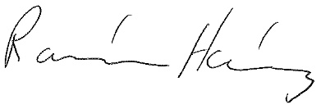

Ramón Hernández

Associate Dean for Student Affairs